# ABC Inventory Management

# Test Scenario: Beta Test Scenario 1

Table of Contents

ABC Inventory Management 1

Test Scenario: Beta Test Scenario 1 1

Scenario Description 3

Version Control 3

User Group 3

Test Log 3

Steps 3

Result Screenshots 4

# Scenario Description

This is the first Beta test scenario of ABC Inventory Management. The test was conducted by a third-party user to check if they could use the system as they wanted. No scripts were prepared so that the user had complete freedom to conduct any activity they wished for. All activities conducted by the user were logged when the user was conducting the tests. These logs were observed and documented in this document by the author. The basic information of the application and a user manual was provided to the user. The user was also given a warehouse staff password and a store staff password.

# Version Control

|  |  |  |  |
| --- | --- | --- | --- |
| Version Number | Date | Author | Description |
| 6.0 | 25/09/2018 | Shirish Maharjan | Initial Draft |
| 6.1 | 28/09/2018 | Shirish Maharjan | First Version (Iteration 6) |
| 6.2 | 10/10/2018 | Shirish Maharjan | Second Version (Iteration 6) |

# User Group

* Pranish Manandhar

# Test Log

## Steps

|  |  |  |  |
| --- | --- | --- | --- |
| Step | Test Action | Expected Results | Pass/Fail |
| 1. | Application is launched. | System displays the ‘Login’ Page with the Username and Password field empty. | Pass |
| 2. | User enters the provided warehouse staff username and password. | System waits for user to click on ‘Login’ button. | Pass |
| 3. | User clicks on the ‘Login’ button. | System grants access to the user and opens the Homepage with Warehouse Staff access. | Pass |
| 4. | User clicks on ‘Logout’ button. | System displays a dialog boxing asking user to confirm the logout action. | Pass |
| 5. | User clicks on the ‘Yes’ option. | System logs the user out and displays the login page. | Pass |
| 6. | User enters the username and password of the Store Staff provided. | System waits for user to click on ‘Login’ button. | Pass |
| 7. | User clicks on the ‘Clear’ button. | System clears the username and password field. | Pass |
| 8. | User enters the username and password of the Store Staff provided. | System waits for user to click on ‘Login’ button. | Pass |
| 9. | User clicks on the ‘Login’ button. | System displays the homepage with ‘Store Staff Access’ | Pass |
| 10. | User tries to add a new staff through manage staff. | Since user has logged in through a store staff account, manage staff is disabled for the user. | Pass |
| 11. | User clicks on ‘Search Product’ button. | System displays the ‘Search Product’ button. | Pass |
| 12. | User clicks on the ‘Detail’ button for a Product already displayed in the list. | System displays the product size that exist for the product selected. | Pass |
| 13. | User clicks on the ‘Detail’ button for the product size. | System displays the location where the size exists along with the quantity in each location. | Pass |

### Result Screenshots

**Step 1**

Application launched, and login page is displayed.

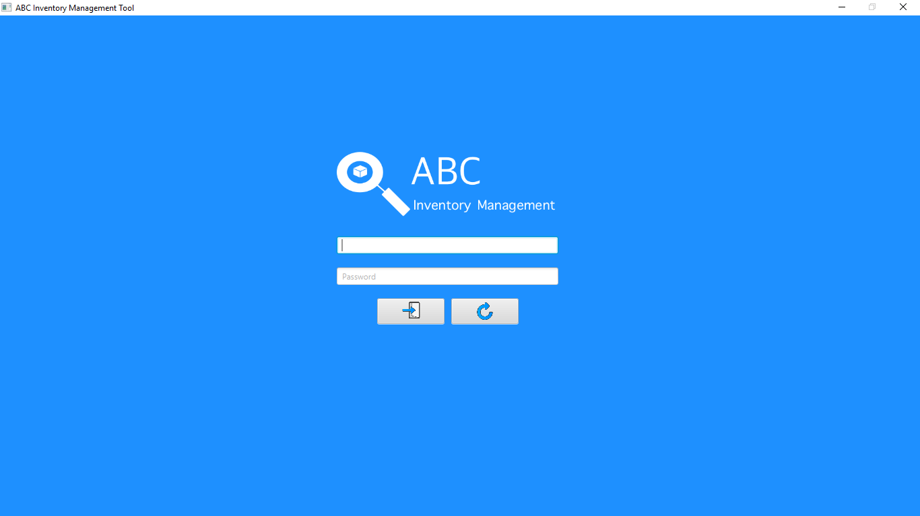

**Step 2**

Username and password are entered, and the system waits user to click on the ‘Login’ button.

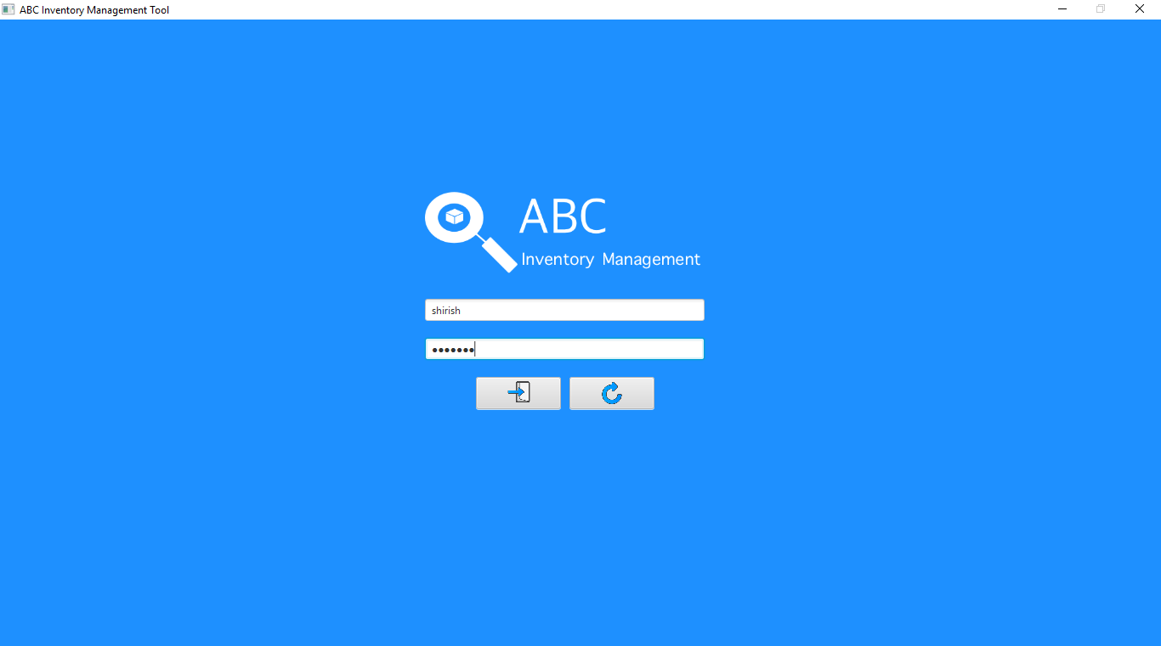

**Step 3**

After the user clicks on the login button, the homepage is displayed with warehouse staff access.

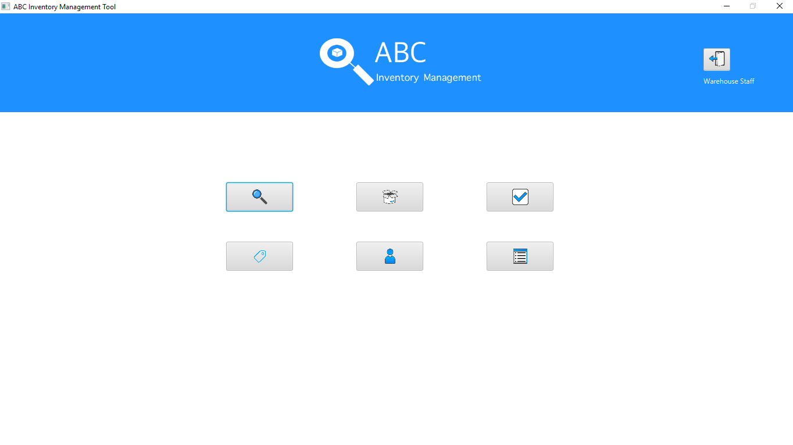

**Step 4**

When user clicks on the logout button on the top right corner, the system displays a dialog box to confirm logout action.

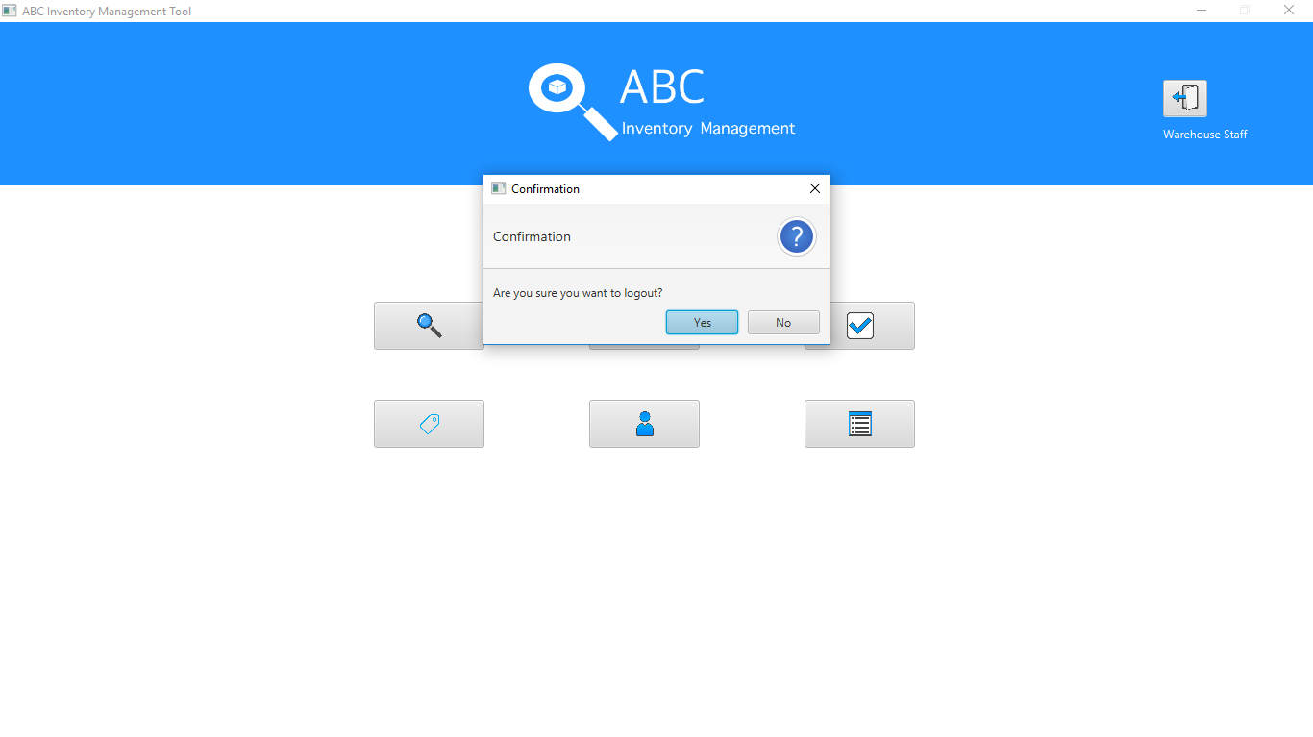

**Step 5**

When the user clicks on yes, the system logs the user out of the system and displays the login page.

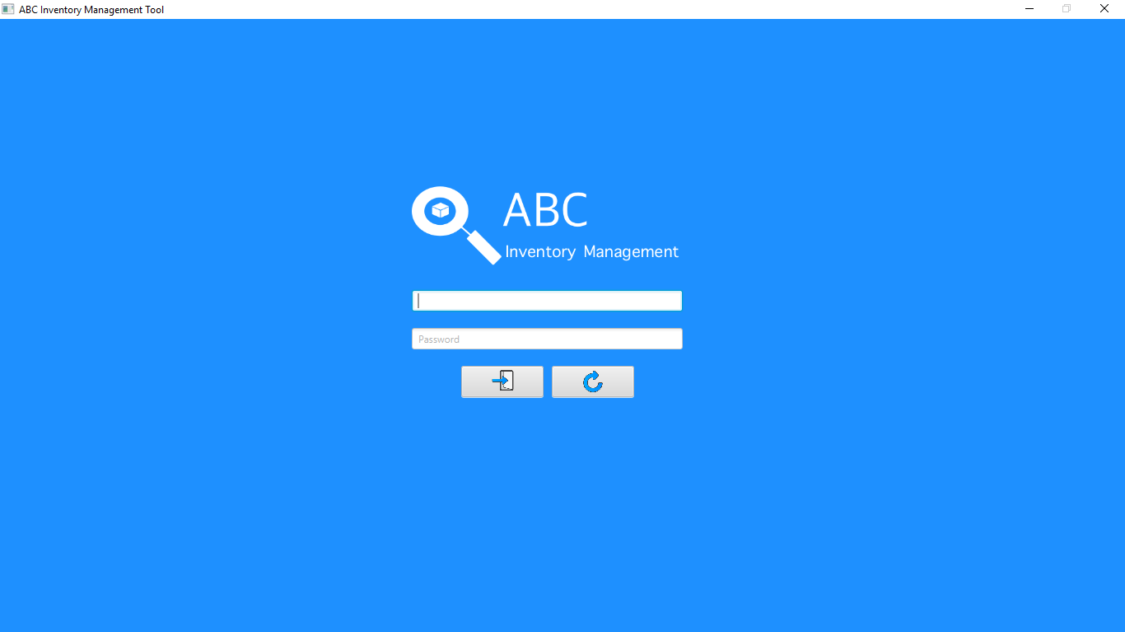

**Step 6**

The user enter store staff login details.

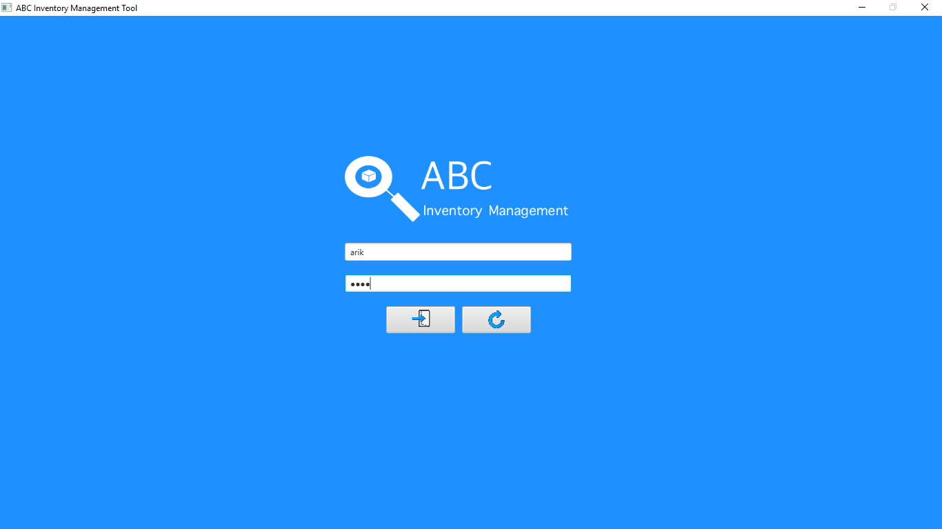

**Step 7**

When user clicks on the ‘Clear’ button, the username and password field is cleared.

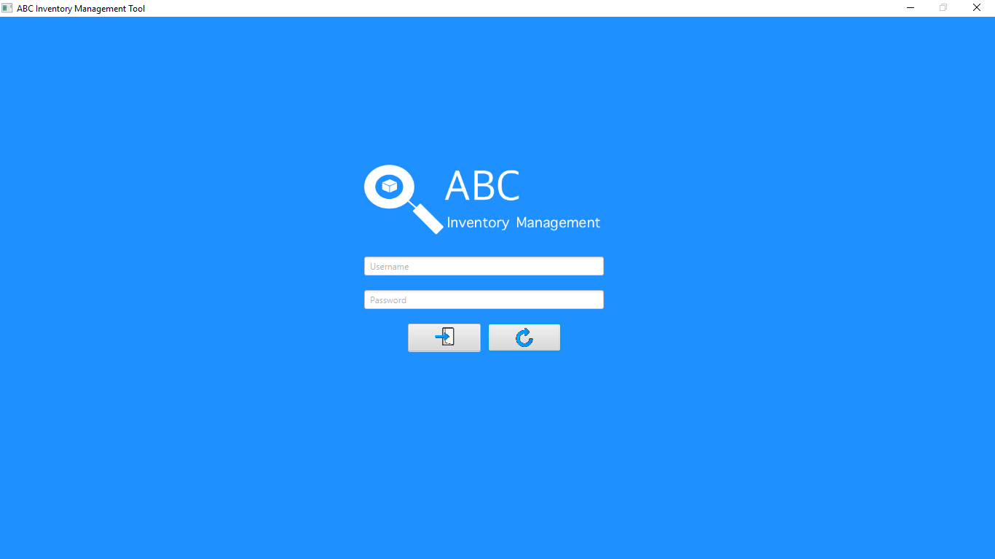

**Step 8**

User enters the store staff login details.

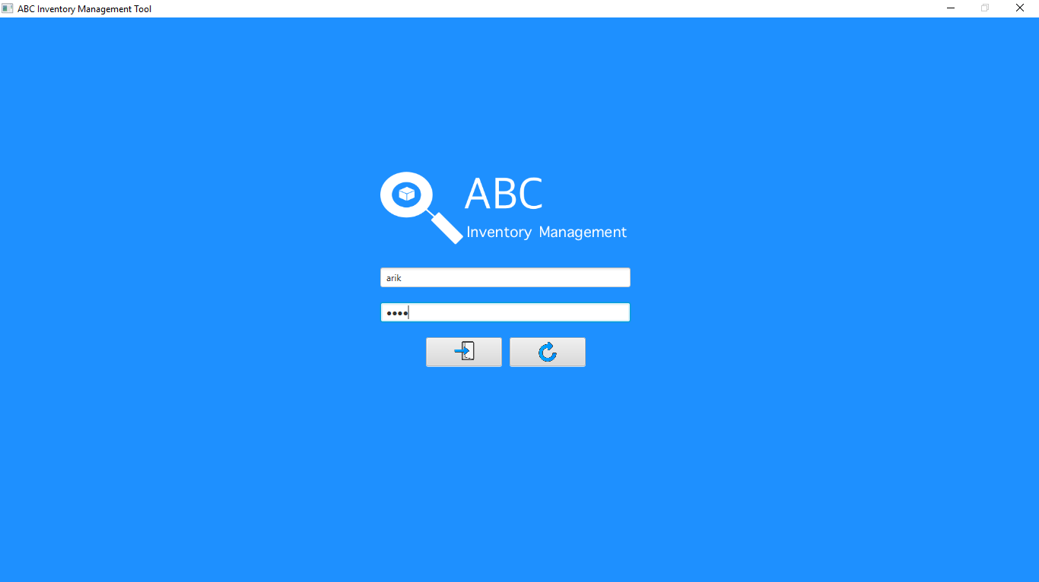

**Step 9**

After user clicks on the login button, the system displays the homepage with store staff access.

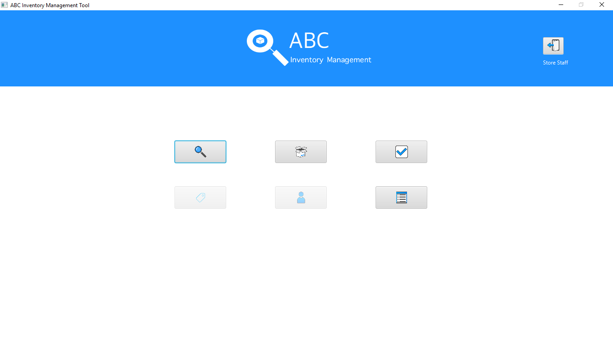

**Step 10**

User tries to add a new staff through manage staff, however since user is logged in as store staff, manage staff and manage product buttons are disabled.

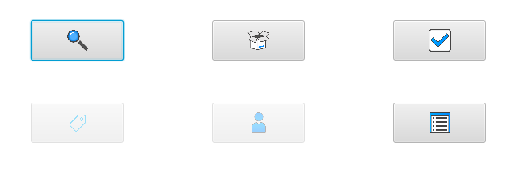

**Step 11**

User clicks on the ‘Search Product’ button instead after which the search product page is displayed. The user then clicks on the detail button for the product A4 which is already displayed.

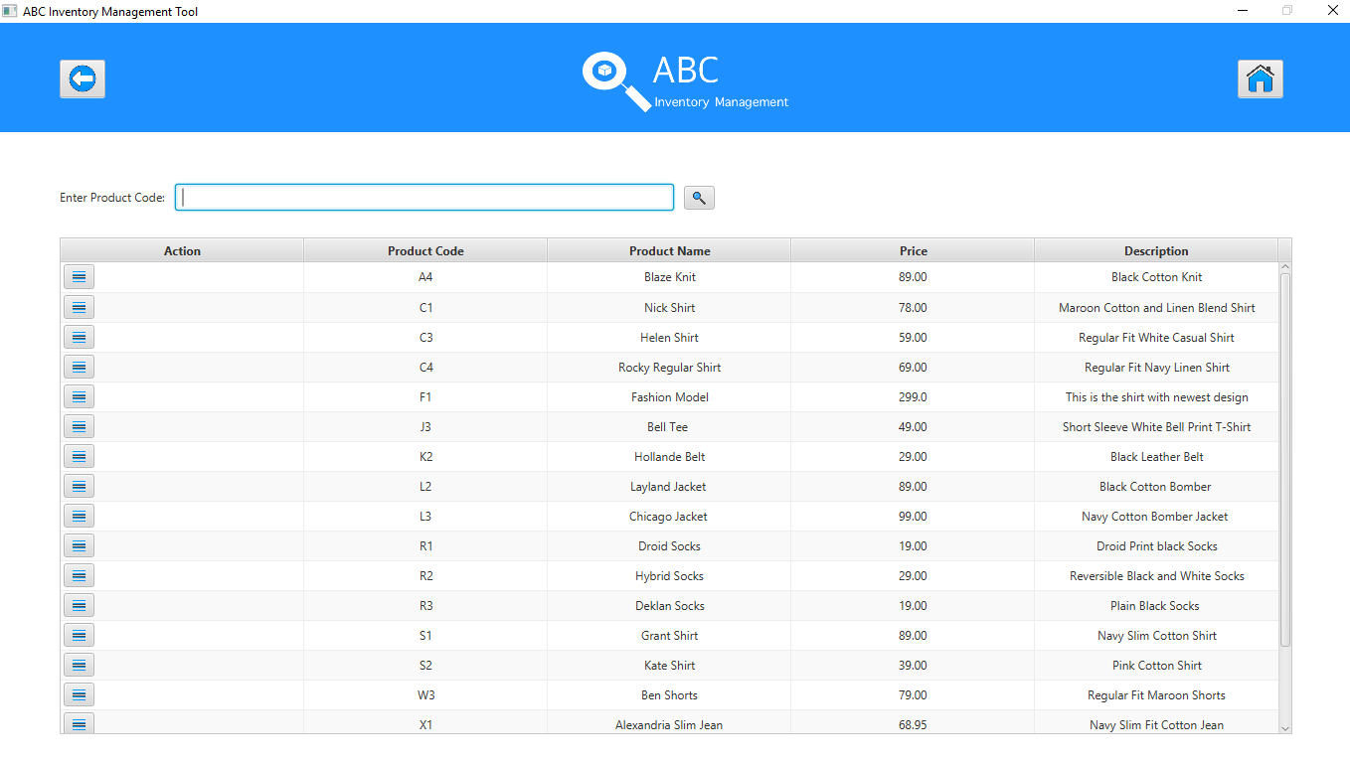

**Step 12**

System displays the product sizes that exist for the product that was selected. 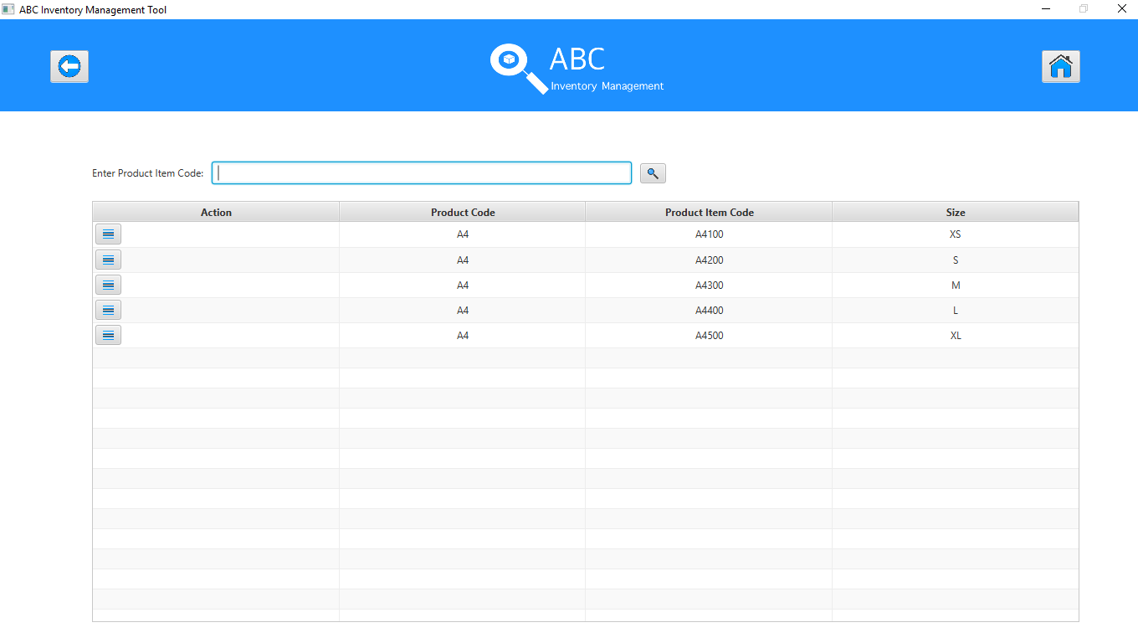

**Step 13**

After details button for the product size M (Code: A4300) is clicked, the quantity in each location is displayed. The location where the size has not been sent yet is not displayed.

